Figure Creation of new key pair

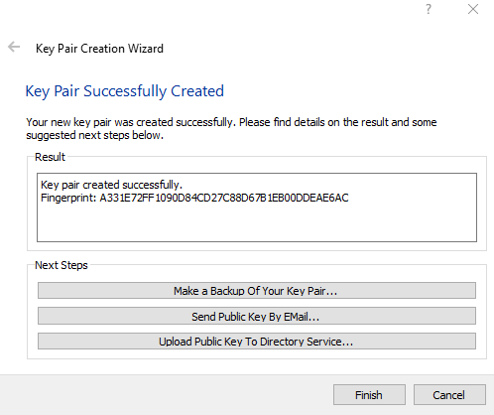

Figure Must be certified to be found on server by other people.



Figure Finding another certificate on the server, in this picture I searched for Krystian but continued the rest of the project with Matt.

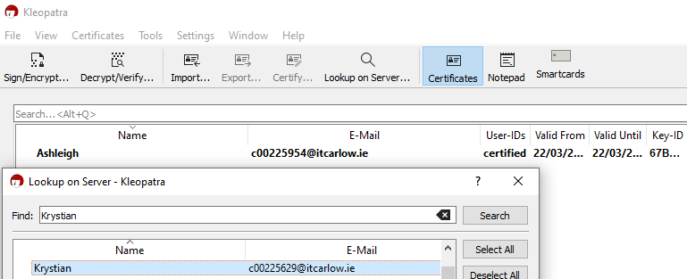

Figure Make a text file to encrypt for sending to partner

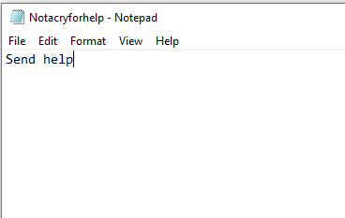

Figure Encrypt using Kleopatra and select the key pairs you plan on sending the encrypted file to. 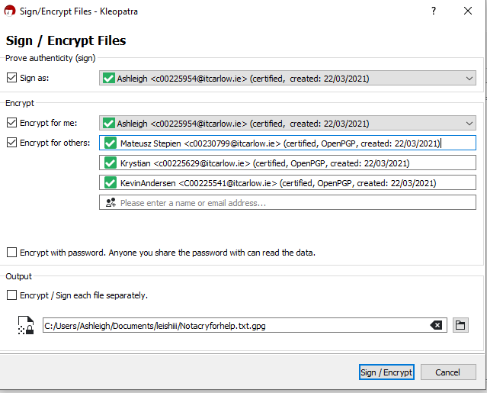

Figure Kleopatra will now encrypt the file for you, get the document created and send it to partners

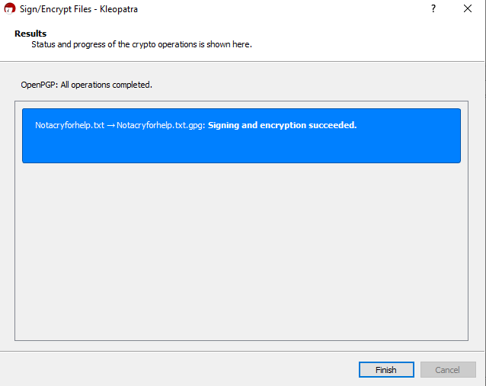

Figure Have a partner send you an encrypted file



Figure Using Kleopatra decrypt it

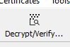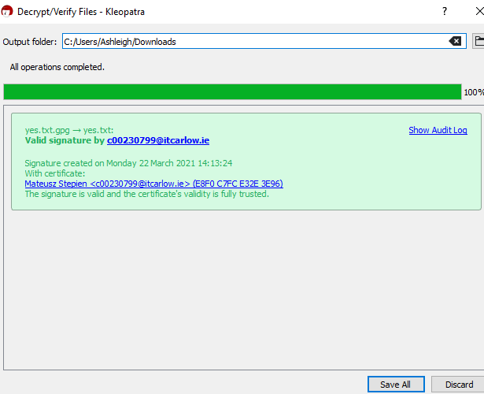

Figure Kleopatra will make a decrypted notepad file

Figure The decrypted file!